A NEW THEORY OF THE ORIGIN OF BIRD FLIGHT – SUMMARY
by Gary Schweitzer Tong (2009)

1. THE CLUE
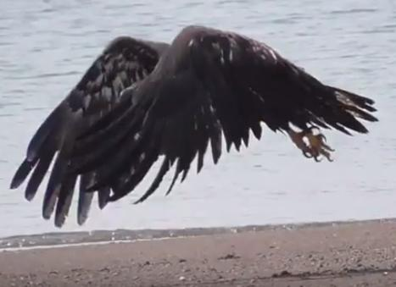
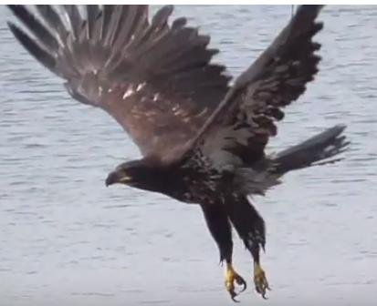
A coordinated rotation of hind and fore limbs in opposing directions is a universal behavior in terrestrial vertebrates. It appears in walking, running, jumping, etc. It can be called coordinated rotation of appendages, or CR.
A considerable repertory of photo and video data clearly shows that in their ground based takeoff behavior large volant birds, like eagles or herons simultaneously extend and flex the legs and wings, demonstrating that CR is present in birds. Examples: https://www.youtube.com/watch?v=0JBSmCbWLOQ
https://www.youtube.com/watch?v=9CDHYwj4QUM

2. THE PROBLEM
This coordinated limb rotation is what all previous ground-up cursorial-based theories of the source of avian flight have utilized in connecting it with running, jumping, and most recently with vertical plane running (WAIR), in all of which arm action assists leg motion. Nevertheless, none of these have offered a fully convincing, unbroken chronology of flight evolution.

3. THE SOLUTION
The reason for this problem lies in the insistent search for a secondary arm flap movement that would aid the primary leg movement in some cursorial locomotive behavior.
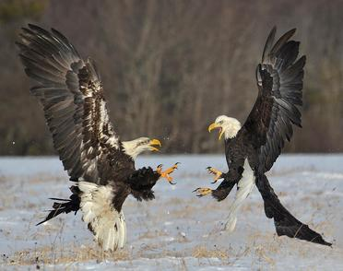
Leaving behind this parameter gives stimulus to considering hind-leg actions which are not locomotive. There is one: striking with the hind-claw, a behavior ubiquitous in avian aggression and one of high fitness selective value.
The sizable and readily available video and photographic data clearly illustrates that striking with hind claws is in all instances accompanied by rapid and powerful wing flaps, whether in the air or on the ground. Asked to verify this three ornithologists contacted have sent confirmation. (We can confidently challenge anyone to show cases where this is not true). The simultaneous clawing movement and wing flapping is a manifestation of coordinated rotation (CR). Seeing such action, it is hard to understand how such commonly observable behavior could have been missed. Examples:
https://www.google.com/search?q=birds+fighting+images&client=firefox-b-1&tbm=isch&source=iu&ictx=1&fir=K4jLks_q79PBIM%253A%252Cvu2mpnxei9HuxM%252C_&usg=AI4_kTzYMyAH975i8gxJV2K1UgvvXrkHQ&sa=X&ved=2ahUKEwi81qmBtOzfAhUrnOAKHYerDW8Q9QEwAHoECAAQBA#imgrc=K4jLks_q79PBIM:

Thus, if small bipedal running carnivorous dinosaurs utilized hind-claw aggression, then lift, without running or jumping was potentially present in the protobird, and only waited for the appearance of feathered flight surfaces on the arms. A concise evolution and chronology of flight origins can thus be described. This theory is Uniformitarian: the element of clawing as the source of takeoff is demonstrated in current bird behavior.

