The Vowel Quadrilateral: Discovering Its Hidden Identity

Highlights need REV
- Discovery: The vowel quadrilateral hides an amazing system
- Discovery: It reaveals an unknown physiological mechanism
- Discovery: It applies to grammar and semantics
- Discovery: It applies to all languages
- Discovery: It provides a novel and extremely useful tool for research

Abstract need REV
The vowel quadrilateral has never been imagined to be more than a formulation serving vowels, however its true identity has been hidden. Actually it is a fundamental physiological framework that when projected as elements of language other than vowels it graphically organizes their positions as if on a chessboard. Just as vowels stand in specific positions in the vowel quadrilateral, so do parts of speech and other elements of speech reside in their own particular quadrilaterals.
These devices map grammatical and semantic components of language and provide a novel and extremely useful tool for research.

Keywords
vowel quadrilateral, parts of speech, grammar, tongue, semantics

This paper presents two innovating topics. – Brings to attention

a) A rigorously proved affirmation that Chomsky’s Universal Grammar exists.
b) This is achieved by the introduction of a so far unknown characteristic of the vowel quadrilateral, which can be recognized as being a Genera Lingual Matrix or GLM.

The GLM is demonstrably shared by all languages. It categorizes various functions of speech, be it grammatical, semantic or cognitive. This can be concluded as the various languages tested for compliance belong to unrelated language families with totally distinct grammatical and semantic character.

This fact infers the total reach of he GLM and that its matrix must unavoidably be an inborn agent in articulation, semantics and cognition. Such situation affirms what Chomsky asserted through sentence analysis. Here it is achieved through an analysis of oral geometricity already manifest in the vowel quadrilateral.

In essence the design of the vowel quadrilateral consists of a horizontal and vertical division of a three-by-three matrix of cells. As examination unequivocally demonstrates, in the case of grammar, parts of speech fall into specific predetermined cells just as vowel do in the vowel quadrilateral. For instance, an unmodified verb occurs in the front high cell, while an unmodified noun belongs in the low back cell. Conjunctions appear in the mid central cell. Similar allocations also occur with semantic and cognitive elements.

Chomsky dealt with sentence structures which are grammatical entities. His critics point out that the significant differences between language families deny this to be true. But it has been established that analyzing a process while staying within its frame field cannot objectively verify its verity; as Gödel's incompleteness theorems argue even if a field is internally consistent it does not truly reflects reality.
On the other hand, it is presented here that outside of sentence structure a different perspective on language is available that settles this disagreement by opening up a physiological window specifically on the oral mechanism. There we can describe and make use of tongue behavior, which as part of the entire working oral structure represents the whole of the behavior within and surrounding the tongue. Chomsky's Universal Grammar emerges embedded in this behavior.

1 The multifarious roles of the vowel quadrilateral

1.1 The vowel quadrilateral
Daniel Jones’s vowel quadrilateral is a matrix of nine (three-by-three) cells which locates the English cardinal vowels in oral space according to the positions and shapes of the tongue. But this configuration is more than what it seems to be; it incorporates a so far unknown system of great importance to be described in this paper.
Jones's endeavor to depict the vowel articulation system was not the first. (Pfitzinger 2011) relates the history of phonetic vowel system: (Robinson 1617) was...the first serious attempts to graphically capture and stylize the tongue position during vowel production...(and) took an introspective pseudo-articulatory approach since the stylized tongue configurations do not reflect articulatory reality...(Wallis 1653)...in his two-dimensional vowel scheme, he differentiates between labial, palatal, and guttural places of articulation, while each can be produced with three different degrees of opening resulting in a total of nine vowels...(Reyher 1679)...arranges the five numbered vowels /a/, /e/, /i/, /o/, and /u/ along a semicircle, assigning the sixth position on the far right to the schwa vowel, which is the central vowel often elided in German...von Kempelen [1791] published his own vowel scheme, based on a five-step parametrization of mouth and vocal tract opening...because he very well realized the existence of “two sluices, holes or gates, which the tone of the voice has to pass, namely that of the tongue and that of the lips...Hellwag [1781] was the first to choose the shape of a triangle for an arrangement of vowels in his dissertation [7] and by that introduced the classical vowel triangle...Forchhammer [1914]...chose the vowel cube...in his search of a systematic vowel arrangement for a world’s alphabet, reasoning that the three-dimensional nature of vowels calls for a three-dimensional coordinate system. The simplest form was, in his view, the vowel cube...finally (Jones 1917) published his primary Cardinal vowel trapezium...at the same time as a disk recording containing his pronunciations of long and short variations of the eight Cardinal vowels...Delattre [et al. 1952]...conducted studies with formant frequencies that are not so much an asset of phonology as of digital vowel production...Kingdon [1964]...was the first to call for more vowel symbols afte the successful introduction of Jones’ system, namely at least 32...The International Phonetic Alphabet between 1988 and 1993 has introduced a three-dimensional diagram modifying Jones' but the simplicity of the latter has been excepted as the standard...The first major change was designed in a joint paper by Ladefoged and Roach [1986] [with a questionnaire resulting in adding the] concept of combining the primary and secondary Cardinal vowel quadrilateral in one...[and] the articulatory feature “lip posture” was included as the third dimension of vowel quality (Pfitzinger 2011).
The latest additions have dealt with lip behavior and the contrast between unrounded-rounded dimensions, however as (Pfitzinger 2011, p. 163), suggests Jones's “system benefited from the covariation of lip posture with vowel height and backness often observed in many languages of the world” and he prefers staying with the elegant simplicity of Jones' system that also happens to be the source of the General Vowel Matrix (GLM) that is the subject of this paper.
1.2 The General Vowel Matrix
This paper demonstrates an unexpected novel connection between the vowel quadrilateral and parts of speech, specifically nouns and verbs. Jones' diagram can be revised and expanded as a framework, the General Lingual Matrix (GLM) in which parts of speech and various grammatical and other functions are systematically categorized. In it, for instance nouns and verbs occupy particular places just as do vowels in the vowel quadrilateral, see Fig.1 below.

1.3 Is there a configuration of verbs and nouns in the vowel quadrilateral ?
Because the vowel quadrilateral precisely classifies vowels by position in a front, central, back vs. high, mid, low three-by-three matrix while the tongue itself is likewise divisible into three parts both horizontally and vertically, into superior longitudinal, vertical/transverse, and inferior longitudinal layers it may be asked whether such segmentation of the vowel quadrilateral merely specializes in vowels or whether it is a non-specific frame in the oral system that would possibly configure other elements of speech.
1.4 This notion arises for the fact that sounds approximating human vowels occur in mammalian voicing and may predate evolution of human speech. The literature does not render animal sounds phonetically and here we can rely on anthropomorphic representations.
1.4.1 Such sounds include “meeow” /miɑʊ/ (cats), as “wa-oo” /ɹɔːɹ/ (lions), “moo” /mu:/ (cow), “wau-ff” /wʊf/, /ɹʌf/, (dogs), /bɑʊ-wɑʊ/), “hoo” /huːl/ (wolves), “heehaa” /hɑ hɑ hɑ/, /hi'jinə/ (hyenas ), “oink” /ɔɪŋk/ (pig), and “hee-haw” /hi:hɔ / (donkeys), and so on. Apparently these sounds, without exception are versions of human vowels limited by animal voice anatomies. All but one of the above possess only three vowels, the so called “triangular” or “extreme” vowels (Catford 1977, p. 184), expressing their essentiality and the effort to articulate these sounds. Since animals lack speech, it can be hypothesized that the framework emitting these sounds is not specifically built for human speech but rather it already exists in mammalian oral structure. This inference is supported in that nature evolves multiple uses for some of its devices for instance elephant's trunk that sucks up water, picks up forage, creates sound or its ear that channels sound, fans the body and loses heat through its large surface—therefore what we know as the vowel quadrilateral format might also perform additional functions.

2 The experiment
An experiment can investigate whether elements other than vowels are systematically distributed in the vowel quadrilateral, i.e. in the GLM. The reason prompting this question was mentioned above in that the three-by-three matrix of the vowel quadrilateral is clearly paralleled by the analogous partitions of the tongue, the horizontal upper, middle and lower layers versus the axial alveolar, palatal and velar sections. This exactly matches the scheme of the vowel quadrilateral and suggests that such three-by-three mapping may be a basic configuration in oral architecture. As for what speech elements might experimentally be placed in the vowel quadrilateral matrix the first possibilities in order of complexity are consonants and syllables. The numerous consonants being highly varying occlusions of the air tract would logically not be easily distributed in the nine cell matrix. Syllables consisting of differently composed consonants and vowels are also too variable to be considered. Moving further up in speech complexity exist words which can be classified in a reduces number of categories as parts of speech and thus can be subjects in the experiment. This is affirmed by (Shapiro et al. 2006): “The most basic grammatical distinctions that can be made are between ‘parts of speech’... and of the parts of speech, nouns and verbs are constant classifications across languages — even languages which do not mark grammatical tense, such as Mandarin Chinese, still treat nouns and verbs as separate classes of words”. Therefore the chief classes of parts of speech namely the noun and the verb are selected as the subjects in this experiment.

2.1 The methodology of the experiment
2.1.1 a noun, such as “(a) garden” in its unmarked form (singular, nominative) will be attempted placement in the various cells of the vowel quadrilateral, and b) the verb “(to) garden” in its unmarked form (without person or number or condition and in the present tense) will be attempted insertion in the various cells of the vowel quadrilateral.
2.1.2 Result: a) it will be found that unmarked noun “garden” will fit only in the low-back (inferior posterior) cell; and b) that the unmarked verb “garden” will fit only in the high-front (superior frontal) cell and in none other, Fig. 1.
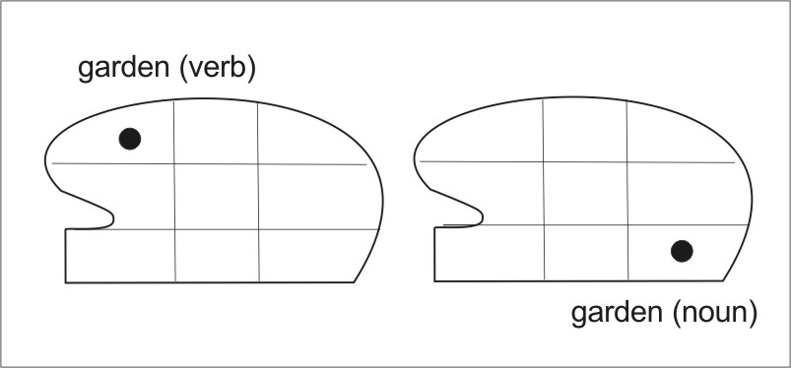
Fig. 1 Placements of verb and noun
in high front and low back cells

2.1.3 That these placements are correct is verified by the fact that when the noun and the verb are repeatedly articulated in alternation they will oscillate between their high-front and their low-back positions. It can be concluded that the so called vowel quadrilateral, now recognized as the GLM classifies not only vowels but parts of speech as well.
Starting with this experiment this paper will show that the vowel quadrilateral (or triangle) unexpectedly turns out to be far more than a phonetic implement; rather it is a multifunctional device providing the format for systematizing several fundamental elements of language, in which not only vowels, but various other functions of language are tabulated. In some of these it is not cell spaces that serve but the axes dividing them. The vowel trapezoid in its generalized roles can be called the General Lingual Matrix (GLM).
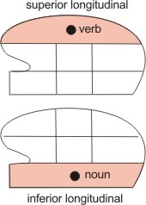
Fig. 2 Placement of verbs and nouns
in superior and inferior longitudinals

2.2 Stable cells in the General Lingual Matrix
Each particular vowel is uniquely associated with one of the nine cells in the 3x3 vowel diagram and these cells are unique stable positions, anchoring the physical setting for a particular vowel. No other vowel but the chosen one can be articulated in that cell and that particular vowel cannot be articulated in any other cell. In this presentation the GLM shows that different parts of speech are also uniquely articulated in specific cells. For instance, two of the eight parts of speech verbs and nouns are universally positioned in such a way that verbs are in the superior longitudinal layer of the tongue and nouns are in the inferior longitudinal layer, Fig.2. At this point particular cells in the layers are not yet considered, although this was briefly mentioned under methodology above. There is also vertical distribution in the tongue (see next paragraph). As precisely as cardinal vowels have unique placements in the vowel quadrilateral, in the GLM nouns, verbs, adjectives, adverbs and conjunctions possess with exact clarity their own unique cells or axes.
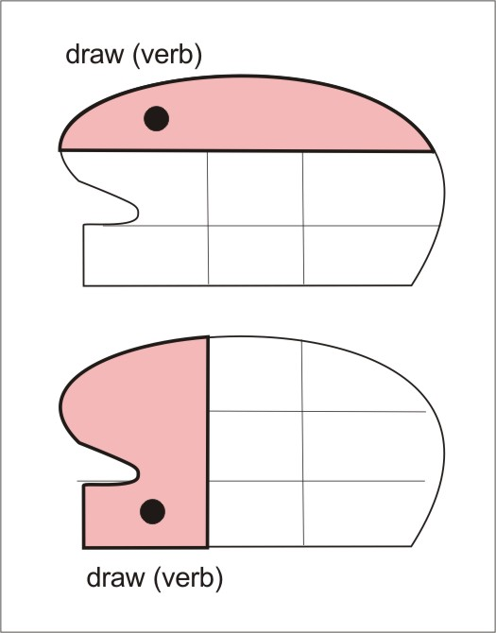

Fig.3 Horizontal and vertical
allocations in the tongue

2.3 General Lingual Matrix---two modes
Following its two way divisibility (see paragraph 1.2) the tongue simultaneously operates in two modes of matrix dimensions. One mode works with the three horizontal layers, i.e., the longitudinal superior, the vertical-transverse and the inferior longitudinal muscles, and the other mode with the vertical divisions, here called sections, namely the anterior, the middle and the posterior sections of the tongue. Parts of speech can thus appear both in one of the longitudinal layers and in one of the vertical sections, not simultaneously, but following the order of the speaker’s perception, Figure 3. Which option is activated and perceived as the prime mover depends on the speaker’s head and body posture. The middle section has not been recognized as independent and here it needs to be anatomically defined. It is the middle part of the tongue body where lingual musculature anterior and posterior to the middle region meet and interact as the agent and antagonist. The anterior and posterior regions of the tongue have been defined as differing in anatomical details: “The body is the largest segment and it is convenient to arbitrarily separate the body into an anterior and posterior part. The anterior body is inferior to the hard palate, the posterior body lies inferior to the soft palate” (Sanders and Mu 2013). However, it was not realized that the two parts importantly operate in a mutual agonist-antagonist relationship and that the middle section is not a discrete anatomical region but is the conglomerate of mutual interaction by the external and internal muscles of the front and back parts of the tongue. On the other hand this mutuality was recognized and explored by (Esling 2005).

2.4 Not only vowels
It has never been established that having stable positions as possessed by cardinal vowels are not restricted to systematizing only vowels. Any oral function is assignable to its own particular matrix setting possessing a stable or semi stable placement and anchoring in oral space. Coughing and swallowing setups occur momentarily while the action proceeds and they are only temporarily stable. The frames of mastication and of speaking are more stable and that of respiration is the most stable. What structural matrix adjectives and adverbs are wihtout degrees of comparison.

2.5 The locations of parts of speech in the GLM
Parts of speech in the GLM are assigned in unmarked form, verbs without person, number, tense or condition, nouns without number or case, and adjectives and adverbs are wihtout degrees of comparison. Verbs occur in the front cell of the superior longitudinal layer of the tongue and nouns occur in the back cell of the inferior longitudinal layer. Pronouns, adjectives, adverbs, conjunctions and articles appear in the mid central cell, Fig. 4. Note that adjectives and adverbs are located not within cells but

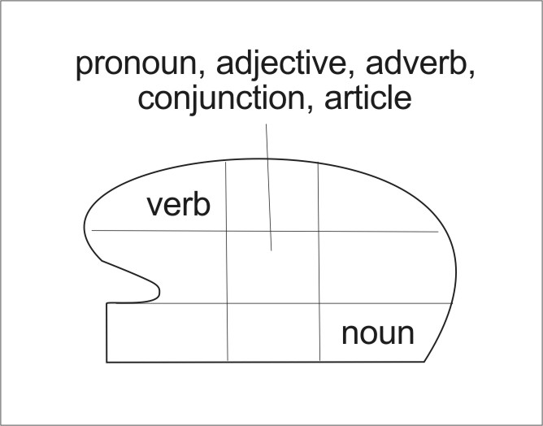
Fig. 4 Locations of parts of speech

on axes traversing the mid cell. This paper covers only nouns, verbs ; adjectives, adverbs and conjunctions will be taken up in forthcoming papers. For pronouns see 2.5.1.​??

In addition, except for those in mid central positions the parts of speech located in horizontal `in vertical front and back lingual sections. Cf. above, The General Lingual Matrix – Two modes (paragraph 2.3).

2.5.1 Pronouns in the GLM
English personal nominative singular pronouns mapped in their particular cells, Fig. 5. It may be hypothesized that because the “I” is subjective and is geometrically and cognitively central to the speaker as well as static it stands in the analog of the cell of the noun, but with the secondary bias by the central tongue section. This input modifies the “I” to become a pronoun. The “you” involves a forward
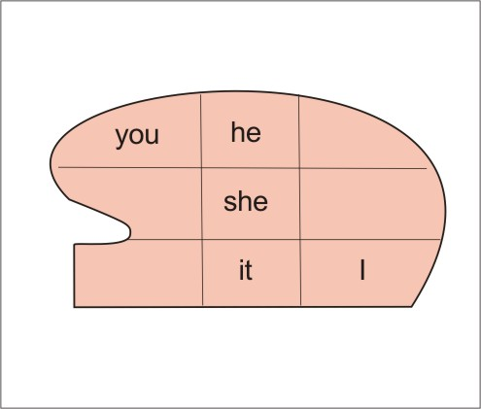

Fig. 5 Locations of English
singular pronouns REPLACE WITH NO FRAME!!!

motion aimed at the person addressed and so it occurs approximately in the verb position analog implying a forward pointing action in the matrix. Again a secondary bias modifies the “you” to be a pronoun rather than a verb. The third person, prior to actual articulation is in the middle column with the two genders and the impersonal pronoun filling the vertical cells, undoubtedly arranged by natural cognition. When the “she” and the “it” are articulted and are ranked functionally as important as the “he”, they are projected into the superior level. \Directionality within the matrix therefore exists since moving between cells possesses bearings.

2.6 The methodology for perceiving GLM place assignments consists of producing the three-by-three matrix empty of contents which can be done by first creating the vowel matrix and then removing its vocalic contents. This blank matrix projected in the oral space can be manipulated by perceiving its various cells or axes and by moving from one cell or axis to another.
Observing the locations of parts pf speech in the matrix is feasible in at least three ways:
a. Simply perceive the location of a verb or a noun in its matricial cell.
b. Perceive the upper level of tongue layers, the superior longitudinal layer without also focusing on the cell divisions in this layer and to observe that any thought or articulation of a verb will appear in the top layer. In contrast a noun will occur in the inferior longitudinal lingual layer. Or more precisely verbs go to the superior front cell and nouns to the inferior back cell, see Fig. 4. Provided the person is its native speaker, the clearest way to show this in English is by using a homonym that is both a verb and a noun, such as “garden” (verb) and “garden” (noun) or “draw” (verb) and “draw” (noun). If such a word is alternately spoken or thought of as a noun and then as a verb, the words will oscillate between their appropriate cells.
It is interesting to also work with “to garden” and with “a garden” to see an variation of the experiment. Unlike the unmarked verb “garden” in its anterior top level verbal cell, when prefixed as “to garden” two cells are taken up, the verbal one plus the mid central one which is the adverbial cell generating the “to”. This cell is secondary and when removed leaves behind the verbal cell. The segment “a garden” behaves analogously, where the “a” is adverbial and removing which leaves “garden” in the nominal posterior low cell.
c. Another method is to produce the vowel quadrilateral and to place a verb in the /i/, or high front cell, and a noun in the low back cell. The latter is most clearly found in non English languages; in English the phonemes /ɑ/, /ɒ/ or /ɑːr/ closest approximate the cardinal low back cell. Either a verb or a noun will perfectly fit into its appropriate location.

2.6.1 Symmetrical locations
The two alternate matricial locations present in the methodology are symmetrical in that a verb appearing in the anterior horizontal placement will simultaneously also appear in the posterior vertical sectional placement, Fig. 2. This was covered in Section 2 Modes.

3 Cadence
The cadential cell is relatively relaxed and allows perception of its matricial placement. Cadence occurs in the last syllable of an isolated word and this cell enables identification of the part of speech the word happems to be. When different parts of speech are pronounced they will be perceived to fall into a particular cell in the GLM. In this methodology verbs and nouns are to be articulated in the least marked dictionary form, with minimal grammatical specifications: verbs in the present tense in the indicative mood without person, number, and nouns singular nominative. The reason for this is that articulating employs interactive multidirectional forces which mask over the primary matricial positions, and in order to see the matricial placement it is important to attenuate the forces producing a monosyllable or a final syllable to the level that allows the articulation to settle in its appropriate cadence. This permits the particular cell to transfer from the actively articulating frame into its cadential frame. This is necessary since speech is created by the two merged actions of articulation and phonation. These form a mutually antagonistic coupling, where they move front and back orolingual parts in opposing directions, cf. (Esling 2005). With phonation removed only articulation remains in place and is the last activity to decay before full cadence can occur.
(Brown et al. 2009) considers the role of phonation to be the most significant force during speech: “The results showed that the strongest motor activation for speech was the somatotopic larynx area of the motor cortex, thus reflecting the significant contribution of phonation to speech production.” At the same time he does not speak of the fact that phonation is the synergistic antagonist of articulation and that it plays a secondary role in articulatory action; phonatioan adjusts to articualtion, not the other way around. This is evident in that whispering still possesses minimal phonation but in silent articulation active phonation is absent.
4 Discussion
The GLM brings to speech studies a new and empirically observable dimension, that of the physio-geimatric function of the lingual matrix.
The literature offers papers that give support to the existence of the GLM. (Scott 2006) writes that “Shapiro et al. (2006) have recently reported a functional magnetic resonance imaging study of the production of spoken nouns and verbs, the results of which indicate that different neural systems are recruited for each grammatical class.” In the GLM verbs and nouns reside in two distinct cells indicating a difference between two physiologically unique classes: in the GLM verbs occupy the superior frontal cell, which is the more active lingual part, being the mobile and unanchored blade in the anterior tongue whereas the noun is in the less active and more rigidly anchored inferior pharyngeal posterior tongue, Fig. 6.
As (Scott 2006) quotes (Shapiro et al. 2006): “There are data indicating that English speakers do not process ‘hammers’ in different neural regions, depending on whether the word was interpreted as a noun or a verb; rather, the common semantic component dominates.”
Thus the undifferentiated blank GLM appears to be the common semantic framework, a single entity including nouns and verbs in which both grammatical forms of “hammers” potentially exist, Fig. 6.
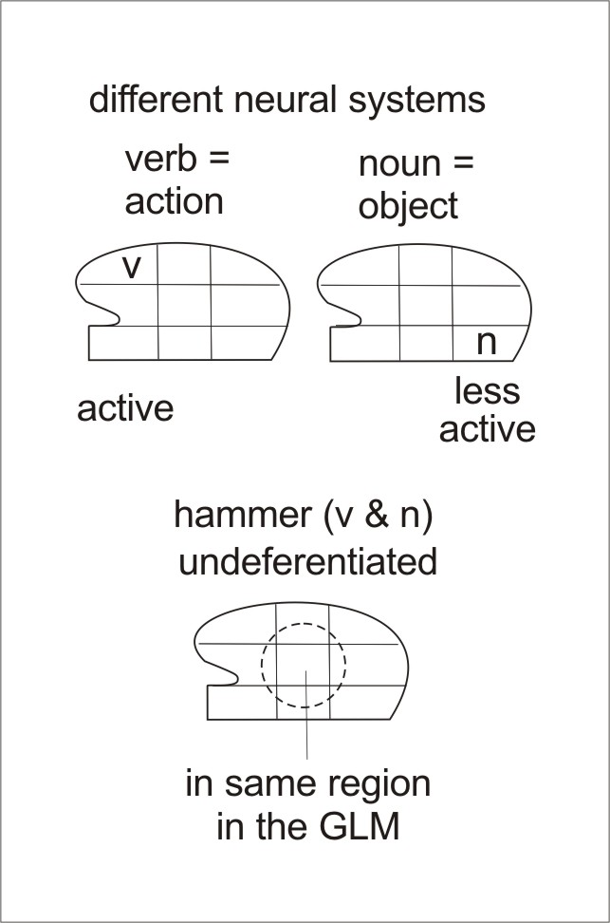
Fig. 6 The different neural systems
and the undifferentiated matrix

Whether an English word that functions both as a noun and a verb, such as “garden” or “paint” is a noun or a verb is determined by context and is not identifiable when isolated. When appearing in the GLM without grammatical marking such a word is still ambiguous in matrricial placement but will occupy its grammatical position as soon as it is conceptualized as either part of speech.
(Cappa and Perani 2003) proposes the question “Are there different neural correlates for noun and verb processing in the human brain? If any, do these differences reflect an underlying semantic distinction (for example, between lexical items referring to objects and items referring to actions) or can they be attributed to syntactic or morphological differences between nouns and verbs?” [A number of findings] “do not give unequivocal support to the contention that brain anatomy reflects grammatical distinctions.”
Indeed, in view of the GLM a distinction between noun and verb apparently exists exhibited as bodily and mental differentiation in their contrasting matricial positions but whether the source of this differentiation is semantic or syntactic still remains unknown. Empirical observation of the GLM distinctions is inadequate to answer this question, although semantic may appear more primitive than syntactic because in comparing the noun
“bear” (the animal) with verb “bear” (to carry) the concept of a dangerous natural foe is more immediate to the mind than the relatively neutral idea of the verb. Similarly with the noun “garden” the immediate perception is a unitary visual notion that is more readily conceived than the verb “garden”, a less direct element consisting of several possible actions. On the other hand, with the verb “run” contrasted with the noun “run” (in a textile) it is the verb that is more rapidly conceived. Evidently the context is a decisive factor.

4.1 Hard wiring of grammar
This paper introduces a grammatical application of the GLM treating parts of speech. It succeeds in establishing the existence of at least one basic function of the hard wiring of grammar based on sentence structure by (Chomsky 1957). Whether sentence structures are biologically defined for all speakers has been questioned, whereas while the concise system put forth in this paper can be challenged it is easily verifiable. The faculty presented here involves neither word order or sentence structure but is embedded in the behavior of speech organs following simple rules and is evidently rooted in the cognition of speech. This biomechanistic faculty is considerably more basic than speech because it has evolved earlier than language. This is well supported in that characteristics pertaining to parts of speech relate to action, substance and appearance and recognition of these and differentiation between them is not restricted the humans. It may be justifiably assumed to be present to different degrees in animals, for instance a dog or a crocodile distinguishes aggressive behaviors from non aggressive one. Another animal moving toward it projects the cognitive properties related to our verb, whereas an animal merely resting on the ground has the qualities of our noun.

4.1.1 Critique of Chomsky
The presentation of GLM, a natural organic function that is now made available significantly neutralizes critic thus far brought up against Chomsky. In an earlier paper (Campbell and Wales 1970) argue that “Chomsky and many of the psychologists influenced by him have failed to give sufficient attention to the environmental factors involved in the development of what they call ‘communicative competence’...[t]his brings us right back to our remarks in section 3 on the subject of distinguishing linguistic abilities from other cognitive abilities. The generative grammarians have insisted upon the methodological advantages for linguistics of making such a distinction. We have argued that in any study of the acquisition and use of language this distinction needs to be revised in various ways – in ways which give explicit recognition to the communicative function of language. In doing so, we have been attempting to bridge the gap between traditional views of language acquisition and views that are dominant at the present time.”

The “communicative function of language” cited in (Campbell and Wales 1970) is implicit in the GLM since it dictates that parts of speech have physiological placements shared by the communicants and therefore the GLM is a communicating function of speech. As for environmental factors affecting speech learning it may be said that the GLM is also environmental, However, in this case it is the internal cerebral environment, not determined by the speaker that sets down both the identities of parts of speech and their order in phrases or in a simple sentences because ordering is inherent in GLM structure.
A study by (Sobecks 2020) states “Language is a highly complex faculty, and since even small children can grasp its principles, Chomsky argues that they must be born with the ability to process and produce language. Since children are able to compose unique, grammatically correct sentences, their faculty goes beyond what could be achieved by replicating learned behavior”. Indeed, there is minimal need for replicating learned behavior because inborn GLM will put parts of speech in appropriate order in the articulation frame. Still, (Sobecks 2020) goes on with “Top cognitive psychologists, including Michael Tomasello and John Macnamara, posit that language ability in children mirrors other learned behaviors. Children interpret statistical information to form grammatically correct sentences, adjusting their speech patterns using corrections from their parents. There is compelling evidence for both theories, but more work must be done to fully understand the development of this incredible human ability”.
GT: As Sobecks admits more work is to be done, and this is exactly what the introduction and further study of the GLM would allow .

4.2 Explanation of an aspect of hard wiring
Why the GLM mapping implies that grammar is hard wired, that it is built into the neural system can be concluded from the fact that a verb, a noun, an adjective, a pronoun or a conjunction is without a single exception uniquely assigned to a particular cell not only in English among the other Indo-European languages but in linguistically unrelated ones like Chinese or Hungarian or Arabic, cf. “Of the parts of speech, nouns and verbs are constant classifications across languages—even languages which do not mark grammatical tense, such as Mandarin Chinese, still treat nouns and verbs as separate classes of words” (Scott 2006) and they also allocate them uniquely in the GLM. Evidently parts of speech generate unique configurations in speech physiology independent of conscious choice and therefore must be automatic functions. Authentic native pronunciation or its optimal approximation is necessary to affirm the predictable results. The present author is bilingual and has also worked on the acquisition of exact native pronunciations. It is self evident that GLM placements are neither learned nor taught since the GLM has thus far not been known. This topic has never been investigated and researchers may either prove or disprove it.

4.3 Versatility of the GLM
How the three-by-three GLM frame consisting of nine cells of is capable to conjure up a number of grammatical and cognitive functions needs explanation. The vowel quadrilateral frame within itself projects different subframes for each vowel. In the same way each function projects a different and unique three-by-three frame that generates a different matrix using appropriate muscular forces focused on one of the cells of the initially erected primary matrix. This cell then becomes the center of a new matrix configured over it. For example, the secondary matrix for adverbs is projected into the verbal cell of the initial primary matrix, since adverbs cognitively relate to verbs. Similarly adjectives as primaries are projected into the now secondary posteriorly inferior matricial cell of the noun to which they are cognitively connected. However, whereas verbs and nouns occupy cells adjectives and adverbs locate on the axes traversing cells. It is such variety of distribution that enables a multiplicity of roles in the GLM. The secondarily projected frames decay to the initially constructed frame. For instance the adjective “yellow” decays into its base noun cell. The possible projections are operated by changes of forces in the external muscles determining tongue positions. The genioglossus, for instance, would protract the projected matrix and the palatoglossus would elevate it whereas the hyoglossus would retract it, and so on. Combining such control with additional extrinsic muscles the tongue can move in oral space and it can build unique matrices in several locations.

4.4 Is the grammatical function of the GLM learned?
The direct connectedness of the tongue to grammar poses the question whether this integration is learned. The answer appears to be negative for a number of reasons. As already stated the GLM being an unknown structure could not have been taught. There is no exception to the unique allocation in the GLM of any verb, noun or other part of speech. The matricial cells for parts of speech in the GLM are the same in all languages. This statement invites proving or disproving it. Once again only the true native pronunciation or its best approximation of any language enables judging this rule and perhaps an ability to accomplish this may be expected of phoneticians with accent specialization.

4.5 Directional movement in the GLM between parts of speech is implicit in that movement from one concept to another takes place in speech and diagrams of grammatical analysis typically indicate this with arrows. In the phrase “she sees the cat” there is transition implied in starting from the cell containing the subject ”she”, through the verb “sees”and arriving at /tongue action. Such movements are physioslogically predetermined and automatically set. A good example of this is how native accent is predefined; it cannot be altered except occacionally by special expertise. There are many types and ranges of directional motions seen in the functional versatility of the tongue exhibited in lingual predation and feeding by the frog, the chameleon, the anteater, the pangolin, the hummingbird, the giant palm salamander, the sun bear, the giraffe, the okapi, the tube-lipped nectar bat, the woodpecker, the echidna, and the alligator snapping turtle, or in olfactory perception by the snake, or in body sanitation in cats or in respiration in dogs, and above all in human speech, and so on. The tongue's ability to organize functions of grammar may now be included.

5 Appendix
5.1 Geometry in language
It can be repeated that the GLM is a geometrical framework operating within the oral and its associated bodily structures and that it shows physical actions and mental concepts mapped by distribution of cell locations. That the GLM works geometrically is corroborated in that geometrico-mental faculties have been and are subjects of research.
This paper only focuses on the unmarked verb and on the unmarked noun and pronoun but papers not yet published will show how the three-by-three matrix also differentiates grammatical categories such as persons and tenses for verbs, and cases and numbers for nouns and pronouns, as well as degrees of adjectives and adverbs and likewise conjunctions and articles. It will also will be described how the geometry of the matrix also connects to the cognition and verbalization of mental moods, to the psychological impacts of colors or of body movements such as hand gestures and other appendicular motions. Existing studies cited below of such behaviors of the geometry and the mind support the faculty of geometry in the GLM.
(Kriegeskorte and Kievit 2013) has examined this topic in a neurological context, cf. “Representational geometry provides a useful intermediate level of description, capturing both the information represented in a neuronal population code and the format in which it is represented. We review recent insights gained with this approach in perception, memory, cognition, and action.” doi:10.1016/j.tics.2013.06.007. https://www.cell.com/cognitive-sciences/fulltext/S1364-6613(13)00127-7.

5.2 Studies of geometry and language
Geometry in Meditation reaches into the organization of the brain because conceptualization or systematization in that organ, whose perceptions are surrounded by the geometry of the environment is built on the simplest natural objects whose forms are those described by geometry. Although the geometrical movements per se in the GLM matrix have never been investigated, geometry and the mind have received attention. How these relate to the GLM still needs more study, but subjected to research the presence of GLM orgatnization and directivity will no doubt be attested.
Geometrico-mental faculties have been and are subjects of research and existing studies on the geometry and the mind referred to below underpin this aspect of the GLM.
Abler writes: “The human mind and the human being, then, are nothing at all what has been thought. Far from being derived in behavior by a process of natural selection, they have their source in geometry” (Abler 2010).
Concerning the directionality in the GLM contrasting between verbs and nouns (Kersten 1998) at https://doi.org/10.1037/0096-3445.127.1.34. reports that
“Extrinsic motion is the motion of 1 object with respect to another object, whereas intrinsic motion is the motion of an object (or its parts) defined with respect to itself. Several experiments are reported that compare the association of these types of motion with novel nouns and verbs. Adult participants demonstrated a bias to associate verbs with extrinsic motion to a greater extent than intrinsic motion and a bias to associate nouns with intrinsic motion to a greater extent than extrinsic motion. These results suggest a division of labor between nouns and verbs, with verbs specialized to convey relational information, whereas nouns are specialized to convey information about individual objects.” Kersten also writes at https://link.springer.com/content/pdf/10.3758/BF03201196.pdf. that “Four experiments provide evidence that people are biased to associate particular types of motion with nouns and different types of motion with verbs…(S)ubjects associated verbs more strongly with path than with movement orientation. In contrast, they associated nouns more strongly with movement orientation than with path” (Kersten 1998). Meditation and geometry reach into the organization of the brain because conceptualization or formulation in the brain, whose perceptions are surrounded by the geometry of the environment is built on the simplest natural objects whose forms are those described by geometry.
Research directly connecting geometry with the conscious mind is mentioned by (Bertol 2017): “Lutz refers to a Focused Attention (FA) meditation which is based on “directing and sustaining attention on a selected object (e.g., breath sensation)” (Lutz et al. 2008). The geometric entities (either physical or visualized) are the object of attention that directs my thoughts, perceptions and movements...My practice could be said to merge FA and movement producing a multisensory engagement of the whole body—including proprioception—toward the geometry form generating a more complete mind-body experience”.
A clinical application of geometry in mediation treating obsessive-compulsive disorder is presented by (Torkamani et al. 2019): “ Farshad’s Geometric Meditation (in short, F.G. Meditation) is a novel holistic style of meditation, based on the principles of mathematics, geometry, psychology, physiology, neuroscience, cognitive sciences and philosophy of mind comprising 64 techniques in three fields of concentration, introspective and mindfulness...[a] recent qEEG-based and polygraphic study on F.G. Meditation demonstrated an increased central theta/beta relative power in central cortical brain regions corresponding to deep relaxation state in test condition compared to the control as well as changes in brain activity were identified before, during and after a number of geometric mediation techniques.”

5.3 The source of mental connection with geometrical fields may in part derive from the coordination of certain cerebral functions with anatomic geometry such as symmetries and linearities in skeletal and muscular design integral to actions and perceptions.
This can be thought to have existed in the earliest animals possessing such geometries as vertical or horizontal bilaterality, that is top and bottom planes or right and left sides.
For instance, in primates the rectangle is perceptively constructable by the projection of the four vertices of the two shoulders plus the two hips and similarly by the two pairs of knees and ankles. The two eyes and their focal point form a triangle. A similar notion appears in (Andersen 2006).

Throughout religious, scientific, and humanist literature on ideas one finds categorical subdivisions that are four in number: the four corners of the Earth, the four cardinal directions, the four proteins constituting DNA, Maxwell's four equations, Toynbee's four societies, Pythagoras’ four elements of arithmetic, Pythagoras’ four elements, Hayden White's four aspects of imagination. The list is endless. From where does the “four” come? Why not five, or six, eight, or nine? Andersen tracks back to the beginnings of arithmetic utilized in the architecture of conceptual thinking. He finds the answer not only in the quadration of the human body as having four sides and giving a stabilizing structure to the brain but equally in the architecture of memory. Using the slot-theory of short-term memory processing, he demonstrates how easily the four-count comes to mind and how the brain resists moving on to five (Andersen 2006, Abstact).

There are a number of other conceptual configurations such as the line of ongoing time, or signs of various shapes such as points, arrows, triangles, circles, exclamation marks, or colors like red versus green, which directly speak to the mind, etc. Human geometrical sensation and control is most evident in various sports, in use of bows and arrows, in ball games, in pool and billiards, in targeting objects at a distance, in arboreal leaping by primates, in prey acquisition by the tongue by frogs or chameleons, etc. All of these deal with distances, with angles, with timing, with reaching moving targets, or with refraction of light rays in water. This is well exemplified by the archer fish, a creature most remarkable in exhibiting the role and mastery of geometry: “In extremely rapid maneuvers, animals including man can launch ballistic motor patterns that cannot immediately be corrected. Such patterns are difficult to direct at targets that move in three-dimensional space, and it is presently unknown how animals learn to acquire the precision required. Archer fish live in groups and are renowned for their ballistic hunting technique in which they knock down stationary aerial insect prey with a precisely aimed shot of water...[and] these fish can learn to release their shots so as to hit prey that moves rapidly at great height, a remarkable accomplishment in which the shooter must take both the target's three-dimensional motion as well as that of its rising shot into account...(m)oreover, all archer fish of a group were able to learn the complex sensomotor skill from watching a performing group member, without having to practice. This instance of social learning in a fish is most remarkable as it could imply that observers can “change their viewpoint,” mapping the perceived shooting characteristics of a distant team member into angles and target distances that they later must use to hit (Schuster et al. 2006).
One study proposes that mental geometry is found in all cultures and therefore is universal; regarding geometry as a universal mental structure (Izardet et al. 2011) writes: “Cheng’s seminal discovery that animals use the geometry of their surroundings to establish their orientation...(and) sensitivity to 2D shapes ...present even in infants, which leads us to postulate the existence of a second cognitive system of geometric content, dedicated to small, manipulable objects and 2D displays, p.320 ...This test therefore reveals a signature of geometric intuitions, by establishing a hierarchy of salience between the different geometric and non-geometric properties of images. This signature is impervious to instruction in geometry, and potentially universal across cultures, p. 000.” The examples outlined above aim at supporting the geomatrricity of the GLM.

