The physiology of vowel harmony in Hungarian – Level 1.
by Gary Schweitzer Tong

A. Fundamental basis
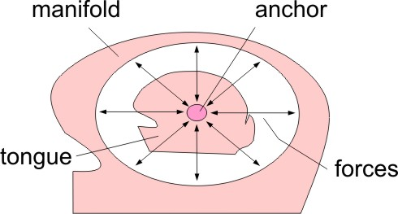
The speech mechanism, like the solar system, consists of two parts, it has an inner center and an outer manifold surrounding it, forming a configuration in which its coactive forces are integrated. The sun in the center pulls on the planets, and the planets pull on the sun. The sun is the central anchor, which keeps the entire movement in order, without it the planets would fly away. Human body movements are analogous; they are anchored by the body's center of gravity, without which we would fail to control our movements. Similarly, the speech mechanism works with a central anchor, which is in the tongue, and with a manifold, which consists of the extrinsic musculature entering the tongue from various directions. In physical terms, the anchor point in the tongue is the lingual center of mass in a particular action of lingual behavior.

However, unlike in the solar system and in human movement, in speech the anchor and manifold roles are interchangeable. That is, the extrinsic muscles and the tongue can reverse roles; the intrinsic anchor can counter and stabilize the action of the extrinsics, and the extrinsics can do the same for intrinsic lingual actions. In kinesiological terms they exchange the roles of the agonist (or prime mover) and the antagonist.
This is one factor that differentiates vowel and consonant generation: for vowels the prime mover is the lingual anchor as it compresses the tongue, generating a tract expansion response by the manifold, while for consonants the roles are reversed, as the manifold compresses the tract, and the lingual anchor expands the tongue. It is important to note that this is most evident in isolated lingual articulation; in full articulation, including the function of phonation, the action is more complicated, but still observable.

B. Horizontal lingual divisions
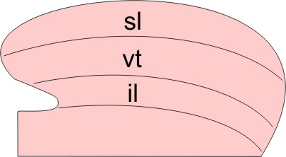
There are three layers of intrinsic muscles in the tongue: superior longitudinal (sl), vertical-transverse (vt), and inferior longitudinal (il). The three layers are completely merged into a single coactive unit, but in different orolingual functions different layers generate the anchoring for that function. That is, a hierarchical ordering takes place between layers according to lingual function: respiration anchoring uses sl, mastication and swallowing employs il, and speech articulation operates with vt.

Once the tongue has been anchored in the vt, establishing the primary speech setting, an additional differentiation between layers is superimposed as a secondary setting over the speech framework.
This secondary differentiation imposed on the layer structure is what generates the agonist anchor node for the articulation framework of a specific language, and hence, of its pronunciation.
These anchoring points differ among languages groups. For example, the frameworks of English and all Indo-European languages are centered on a superior longitudinal node, Semitic and East Asians speakers work with the inferior longitudinal, and languages with vowel harmony use the vertical-transverse layer. This phonetic anchoring is perceivable as the immediate presetting in initiating speech action, just prior to preparing the syllable frame to be produced.
To support this fact, I have personally recorded samples of the authentic native pronunciations of ten different languages, in a wide phonetic range, and hope to demonstrate that correctly locating the defining phonetic anchor of a language makes this possible. The languages are Arabic, Chinese, French, German, Hebrew, Hungarian, Italian, Japanese, Russian and Tamil. The contents of the samples vary between word lists, phrases and text. These mp3 audio files are at:
http://www.garystong.com/Pronunciation/Samples

C. Vowel harmony in Hungarian -- the base level

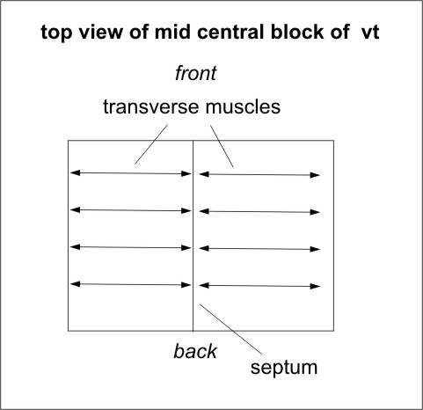
The phonetic articulation anchor of Hungarian is located in the vertical-transverse layer. Here we cover not the relationship between anchor and manifold, but only the mechanics of the anchor itself. The anchor is ideally just a physical point, a center of mass, but in practice it has dimensions, occupying a small region. We can refer to it as the "vt block". This block, located in the vertical-transverse layer of the tongue is by definition composed of vertically and transversely oriented muscular fibers.
The vertical ones vertically compress the tongue, and the transverse ones compress it laterally. Importantly, the transverse musculature is divided into two divisions by the septum, or middle wall, of the tongue, into a right and a left section.

The origin of the muscular fibers of each section is at its own side of the septum, and each section inserts into its appropriate edge of the tongue. Since the forces can exert pull coming from either the septum or from the tongue edge, they may pull either medially or laterally. In other words, they can configure the vt block in two contrasting states.
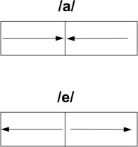
It can be observed that in the case of narrowing during articulation, the vt block acts as the anchor node of the phoneme /a/, while if extended, the block becomes the anchor node of /e/. Since the vertical and transverse fibers interdigitate and overlap, and are also coupled as mutual antagonists, they form a strong, close-knit bond. Moreover, the directions of the two are at 90 degrees to each other. For these reasons the state of the vt block, in both the /a/ or the /e/ mode is relatively rigid, and to reverse the direction of forces, whether they are inward of outward, requires additional externally coming forces. Therefore, to alter the /a/ anhoring to that of /e/ and vice versa needs more effort than moving from /a/ to /o/, or /e/ to /i/, or /a/ to /i/, etc., in which cases the alteration employs forces external to the vt block, those that protract, retract, elevate, depress the tongue as a whole. Remaining in either the /a/ or /e/ orientation of the transverse fibers is, thus, significantly biased against a change and facilitates such sequences of articulation as "ablakban" vs. "ablakben", "kezemben" vs. "kezemban," or "haladhatattannal" and "legeslegmegengedettettebbeknek".

The above offers the physiological explanation of Hungarian vowel harmony at the base level. The various types of exceptions to this basic rule are explained at the next level.

